Assignment 7
Name :- Raghav Anil Bhise
PRN :- 22311792
Roll no.:- 391061
Title :- Develop a Text Preprocessing and Analysis Application using NLTK

1. Aim
To develop a Python-based Natural Language Processing (NLP) application using the NLTK library for performing text preprocessing tasks such as tokenization, stopword removal, Part-of-Speech (POS) tagging, lemmatization, and basic text analysis.

2. Objectives
- To understand the basics of Natural Language Processing.
- To learn how to use the NLTK library in Python.
- To perform sentence and word tokenization.
- To remove unnecessary words (stopwords).
- To apply Part-of-Speech tagging for grammatical analysis.
- To perform basic text processing such as lemmatization and word frequency analysis.

3. Theory
Natural Language Processing (NLP) is a branch of Artificial Intelligence that enables computers to understand, interpret, and process human language. Text preprocessing is an important step in NLP that converts raw text into a structured format suitable for analysis.
NLTK (Natural Language Toolkit) is a popular Python library used for working with human language data. It provides tools for tokenization, stemming, tagging, parsing, and semantic reasoning.
Important preprocessing steps include:
Tokenization: Splitting text into sentences or words.
Stopword Removal: Eliminating common words such as “is”, “the”, “and”.
POS Tagging: Assigning grammatical categories like noun, verb, adjective.
Lemmatization: Converting words into their base or dictionary form.
Frequency Analysis: Counting occurrences of each word in the text.
These steps help prepare the data for further NLP tasks such as sentiment analysis, chatbots, and information extraction.

4. Software and Tools Required
- Python 3.x
- Google Colab / Jupyter Notebook / VS Code
- NLTK Library

5. Algorithm
- Install and import the NLTK library.
- Download the required tokenizer and tagging datasets.
- Provide input text for processing.
- Perform sentence tokenization.
- Perform word tokenization.
- Remove stopwords from the text.
- Apply POS tagging on filtered words.
- Perform lemmatization.
- Calculate word frequency.
- Display the processed output.

6. Program & Output
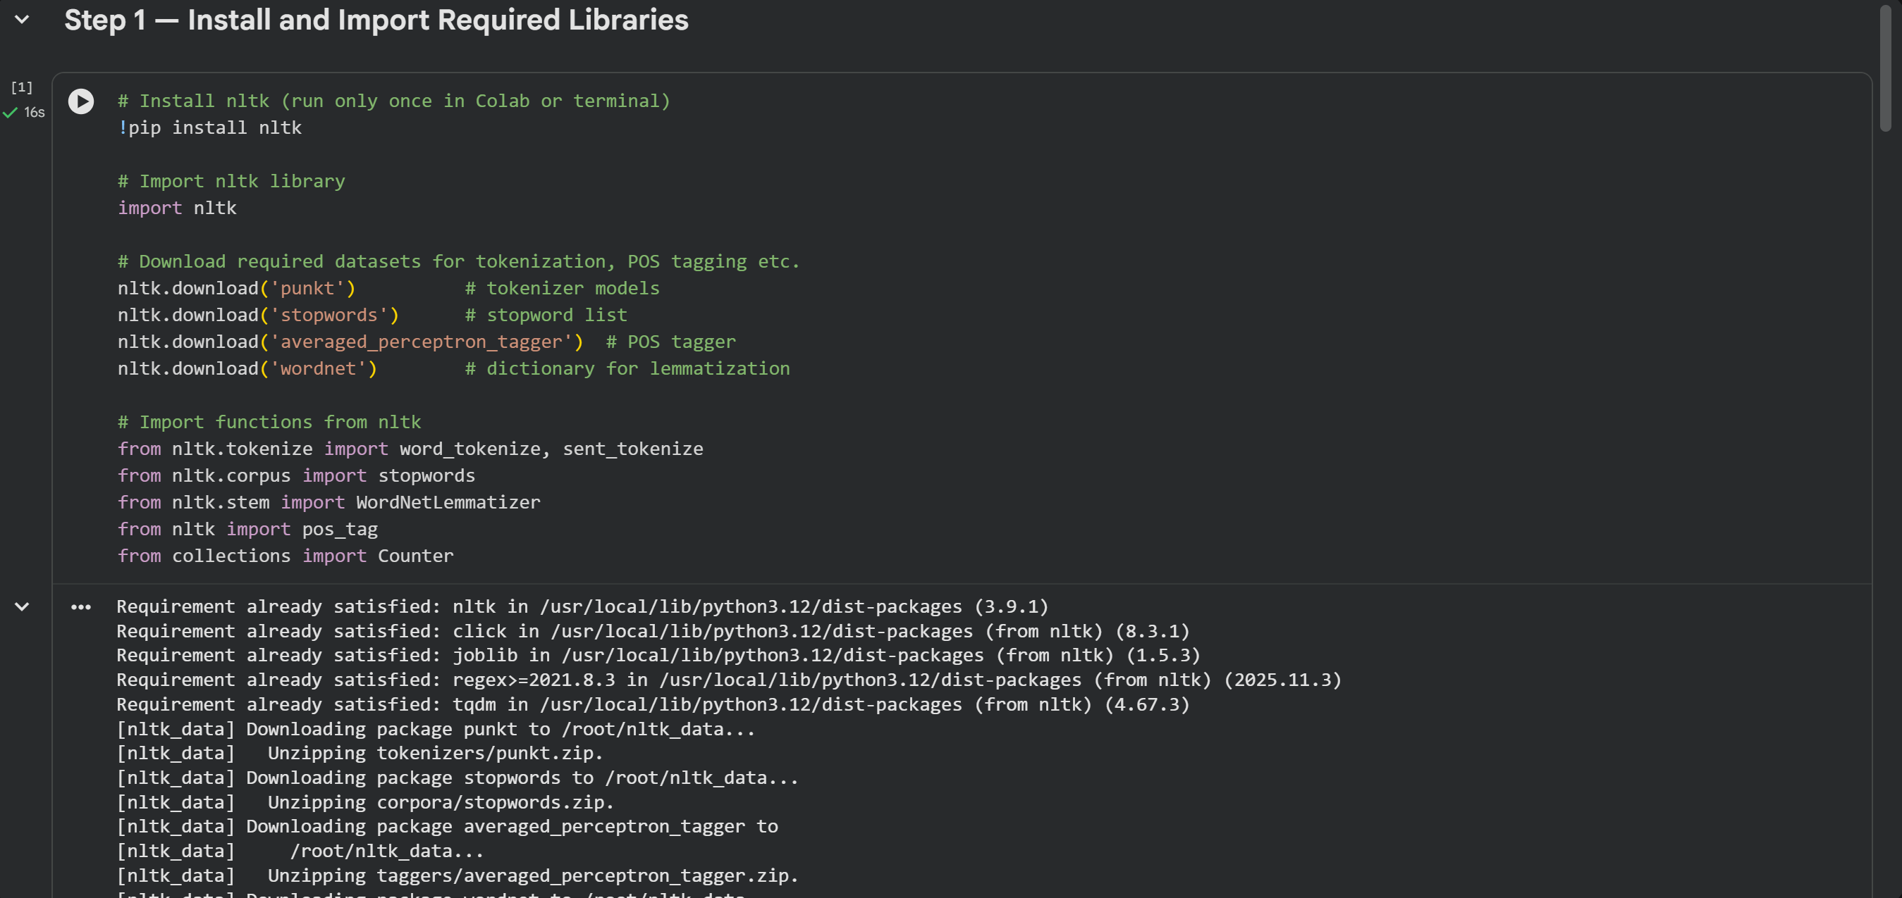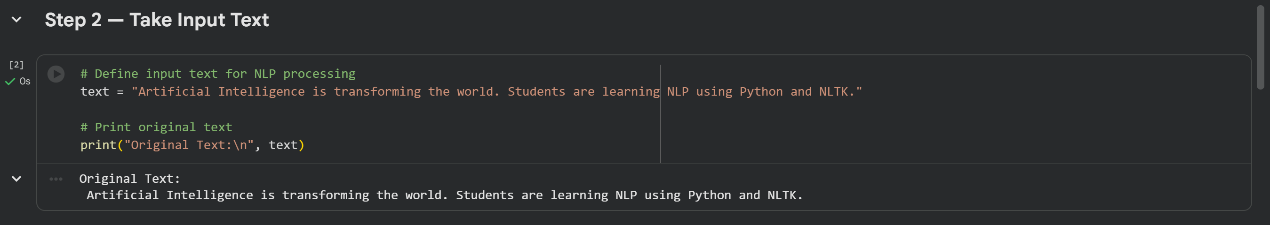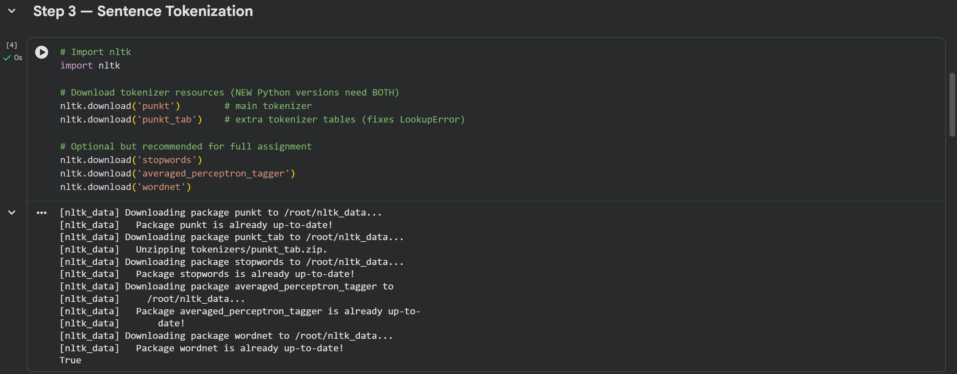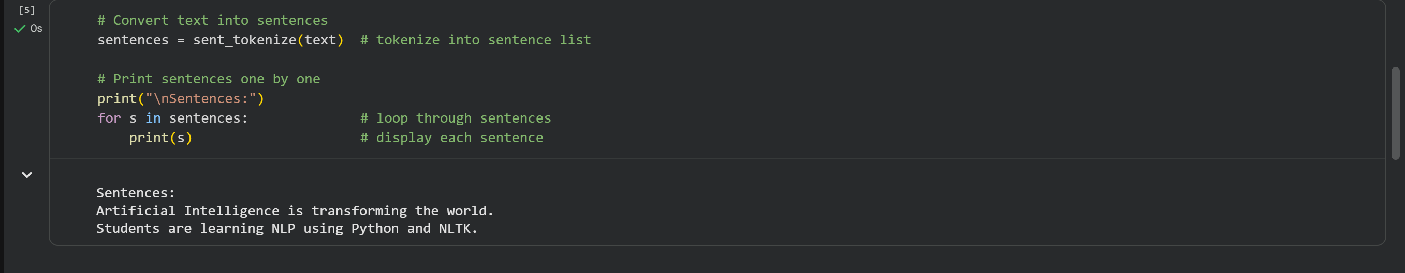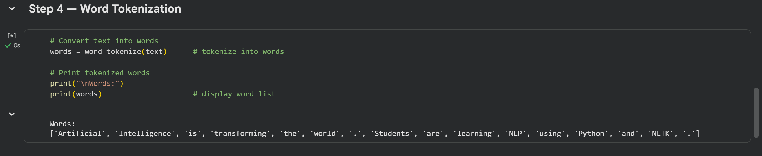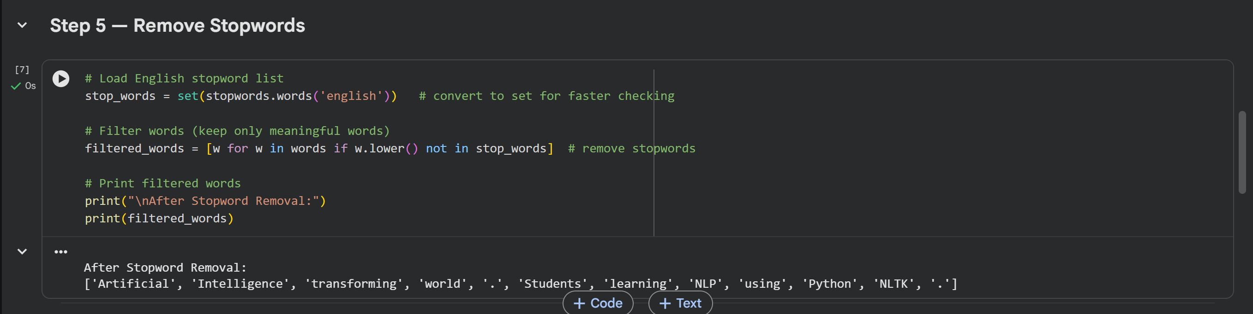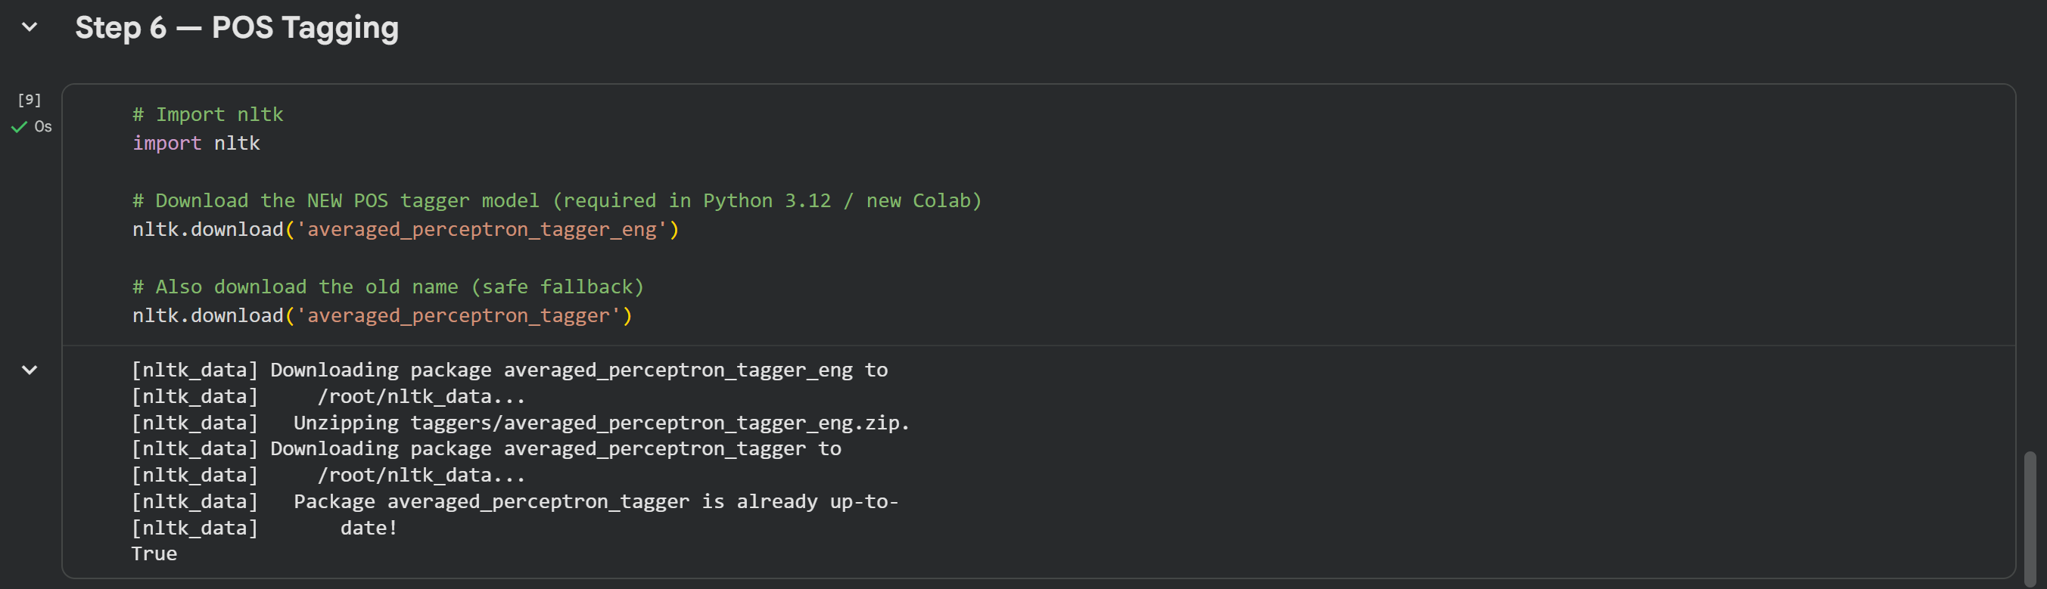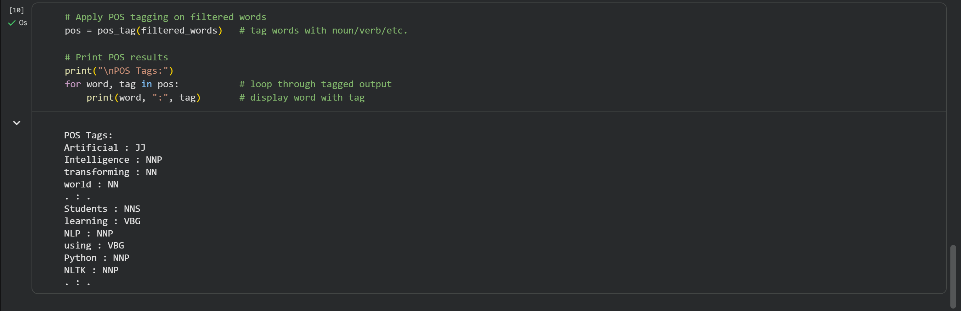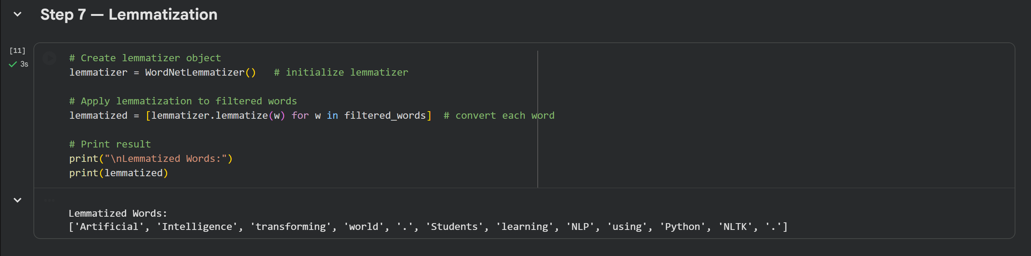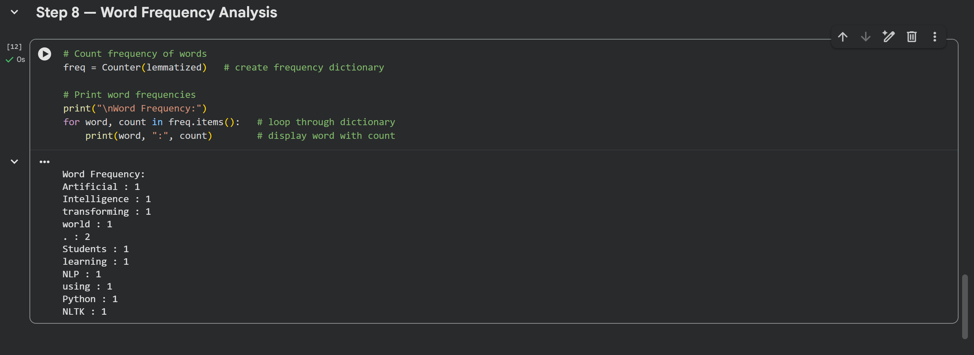

8. Result
Thus, a text preprocessing and analysis application was successfully developed using Python and the NLTK library. The program performs tokenization, stopword removal, POS tagging, lemmatization, and frequency analysis on the given text.

9. Conclusion
The experiment helped in understanding the importance of preprocessing in Natural Language Processing. Using NLTK, various text analysis tasks were performed efficiently. This application demonstrates how raw textual data can be cleaned and structured for further intelligent processing.

